

April 10, 2025

Leland Dudek

Acting Commissioner

Social Security Administration

6401 Security Boulevard Baltimore, MD 21235

Acting Commissioner Dudek:

We write to express our strong outrage and deep concern over the Social Security

Administration’s (SSA) recent actions to slash the agency’s workforce and reported decision[1] to make even more severe layoffs in the coming days and weeks. Your reckless actions have already inflicted a devastating toll on Oregonians and Americans’ access to their Social Security and Supplemental Security Income benefits.

According to agency data, staff in the Warrenton and La Grande field offices in Oregon declined by at least twenty-five percent as a result of your disastrous decisions to reduce the agency’s workforce, and the field office in The Dalles also saw a substantial drop in workers. These three rural field offices already faced staffing shortages before these cuts, with just twenty combined employees serving more than 232,000 Oregonians in ten counties and parts of Washington and Idaho.

As you know, nearly every American interacts with SSA at the pivotal moments of their lives. Access to in-person services is especially important for each of those moments, especially for people who have difficulty speaking by phone, who lack reliable internet access, and who have difficulty understanding program rules. Any disruption in service, especially interruption of benefit payments, can be financially devastating for families. For many of these Oregonians, field offices are often their only channel of service. These field offices are located in predominantly rural areas, with the nearest field office more than 50 miles away from many users. Additionally, more than 400,000 Oregonians lack internet access at home because the state’s size and rugged terrain make it costly and difficult to build broadband infrastructure. Without in-person services, if those Oregonians have difficulty using a phone they are 100 percent cut off from their benefits.

At a time when field offices across the country are feeling these staffing cuts, promises of ‘technology’, remote workload sharing, and staff relocations to affected field offices do little to address the overarching staffing demand given the case volume. Simply put, your decisions jeopardize Oregonians’ access to their Social Security benefits without providing any substantive plans to provide quality service to these communities.

Page 2

We urge you to immediately reverse these changes and work to rebuild SSA’s workforce so it can serve the millions of Oregonians and Americans who depend on Social Security.

Sincerely,

|  |  |
| --- | --- |
| Janelle S. Bynum  Member of Congress | Val Hoyle  Member of Congress |

|  |  |
| --- | --- |
| Andrea Salinas  Member of Congress | Suzanne Bonamici Member of Congress |

Ron Wyden Jeffrey A. Merkley

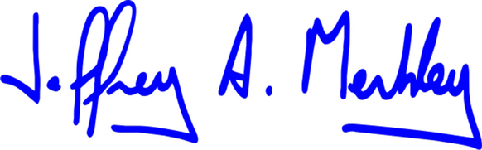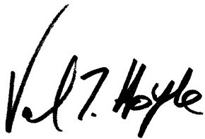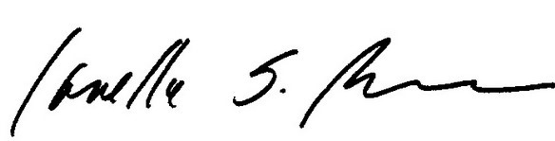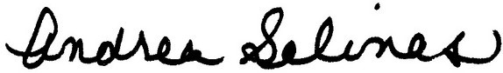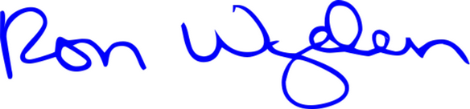

|  |  |
| --- | --- |
| United States Senator  Ranking Member, Committee on Finance | United States Senator |

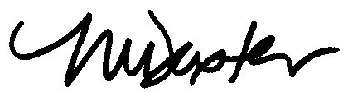

Maxine Dexter

Member of Congress

1. https://www.washingtonpost.com/politics/2025/04/04/social-security-layoffs-trump-musk/