

October 16, 2025

The Honorable Kristi Noem

Secretary of Homeland Security

U.S. Department of Homeland Security

2700 Martin Luther King Jr. Ave. SE

Washington, D.C. 20032

Dear Secretary Noem,

We write to express serious concern about the Department of Homeland Security’s excessive use of force and agents performing crowd control in Portland, Oregon, and the lack of transparency around the Department’s presence and activities in our community. Once again, we urge you to deescalate tensions by withdrawing the federal agents that you have recently deployed.

Your federal agents weren't invited, they aren't needed, and their presence has fomented the very violence you claim they are there to prevent. Photos and videos from our constituents and local media make clear that federal agents are needlessly using tear-gas against peaceful community members. Reports indicate, and videos show, that unprovoked federal agents have charged and knocked down peaceful protestors, including seniors and an elderly Vietnam war veteran. Constituents told us that federal agents have deployed unknown projectiles that have injured them. Many federal agents are fully masked and are continuing to hide any identifying information, which prevents our constituents from filing reports about any federal agents’ misconduct.

The Cottonwood School, a K-8 school located adjacent to the Immigration and Customs Enforcement (ICE) Macadam facility, made the difficult decision to find a new location in August because of the harm of ongoing exposure to tear gas and other munitions. Residents at Gray’s Landing, an apartment complex next to the facility that is home to many disabled veterans, continue to express deep concern about the effects of this ongoing exposure.

This is not the first time our constituents have experienced such excessive use of force by Department of Homeland Security (DHS) federal law enforcement. In 2020, federal agents responded to largely peaceful First Amendment activity by firing “less-lethal” rounds at protestors and by using tear gas on them night after night. The use of tear gas was indiscriminate, and chemicals contained in these aerosols spread to surrounding areas on a nightly basis. In fact, the City of Portland and Oregon Department of Environmental Quality identified a higher presence of cyanide and heavy metals near the sites where federal law enforcement personnel were deployed, and environmental groups expressed contamination concerns in the groundwater and Willamette River. Residents of downtown Portland were exposed to these dangerous chemicals regardless of their participation in the protests, and at least two dozen women who were exposed to tear gas in Oregon reported significant abnormalities in their menstrual cycles, which Oregon physicians believe to be connected to the use of chemical agents.

Crowd control agents, like tear gas, are indiscriminate by nature, making no distinction between a peaceful protestor, a bystander, a child, or an individual with a serious respiratory condition. The harmful impacts of tear gas have been well-documented: exposure can lead to pained and blurry vision, coughing, choking, and difficulty breathing, particularly in people with asthma or other respiratory conditions. The Centers for Disease Control and Prevention state that high doses can cause chemical burns and respiratory failure leading to death.

Medical experts have attributed various health concerns to the acute exposure of tear gas and other chemical Page 2

agents, and health experts continue their research to understand the long-term impacts of exposure. Environmental groups have also expressed their serious concern about the spread of such chemicals and its harm to the health of local communities and surrounding wildlife.

The excessive use of force by DHS federal agents have escalated tensions on the ground, eroded the trust between our community and law enforcement, and put our constituents in harm’s way. We continue to be deeply disturbed by your Department’s activities in Portland, and we urge you to remove these unwanted federal agents as swiftly as possible.

The health and wellbeing of our constituents is a top priority. Accordingly, we request also that you provide the following information by no later than October 17, 2025:

1. How many federal law enforcement agents are currently deployed in Portland in response to activities around the ICE facility and other federal buildings?
   1. What is the breakdown of agents by component within DHS, including dates of deployment.
   2. For each component, also provide the specific authority under which the component agency is acting, a description of how these deployments advance the component’s core mission, and a copy of all applicable use of force policies.
2. Are all federal agents deployed identifiable by badges with names and personnel numbers?
   1. What uniforms, identification, and equipment do personnel participating in these deployments wear and carry?
   2. Please provide any relevant policies and procedures, either at the time or created since, with your response.
3. Who is directly in charge of the DHS federal response on the ground in Portland, Oregon? What is the chain of command at the relevant agencies?
4. Is there any type of cross-deputization with federal agents deployed to Oregon?
5. Please provide a list of all equipment that DHS personnel have used in connection with their deployments in Portland, Oregon, and their corresponding material data sheets identifying the manufacture and source of equipment.
   1. List tear gas and pepper spray used by federal agents in Portland, Oregon—including all aerosolbased crowd control agents that may contain oleoresin capsicum (OC), chloroacetophenone (CN), 2-chlorobenzalmalononitrile (CS), and hexachloroethane (HCE).
   2. List any rubber bullets, projectiles, flash bangs, and all other crowd control equipment used by federal agents in Portland, Oregon.
6. Constituents have expressed concerns around the possible use of hexachloroethane (HCE) smoke, commonly referred to as HC smoke, at or around the ICE facility in Portland, Oregon. Are any of the federal agents deployed to Portland authorized to use this equipment? If so, please detail the circumstances around use of HCE smoke and frequency of use in Portland.
7. What guidance did DHS personnel receive, if any, regarding the operating procedures for engagement with protestors, members of the press, and other civilians? Please include any federal guidance and DHS subcomponent policies on the use of chemical agents, including HCE smoke, OC, CS, and CN gas.
8. What processes do DHS and its component agencies follow to determine whether to use tear gas and other crowd control agents?
9. In the past, we have seen evidence suggesting that tear gas from expired cans has been used in Portland. Has DHS and its component agencies used expired tear gas or other expired chemical agents in

Portland? What steps have been taken to ensure that your personnel are not using expired chemicals?

Page 3

1. Are there any undercover officers associated with this deployment in Portland? If so, what protocols are they required to follow? Which agencies are employing these undercover officers and how many are doing this work in Oregon? Please describe their mission and relevant training.
2. What training and guidance did the federal agents receive on how to interact and respond to protestors? Did this training include nonviolence means of de-escalation? Please provide copies of rules of engagement with protestors, and in particular, please identify any policies that authorize violence against peaceful protestors.
3. What legal limits are there regarding federal agents who are operating at a significant distance from federal property?

Sincerely,

Ron Wyden Jeffrey A. Merkley

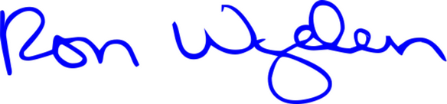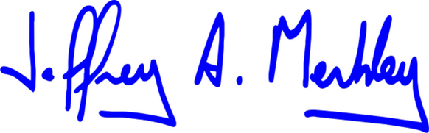

|  |  |
| --- | --- |
| United States Senator | United States Senator |



Suzanne Bonamici Maxine Dexter



Member of Congress Member of Congress

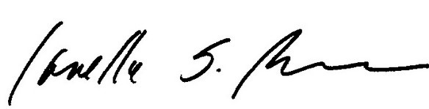

Janelle S. Bynum

Member of Congress