

April 30, 2025

The Honorable Pam Bondi

Attorney General

U.S. Department of Justice

950 Pennsylvania Avenue NW Washington, D.C. 20530

Dear Attorney General Bondi:

We write with serious concern about the termination of critical Department of Justice (DOJ) grants supporting public safety and law enforcement in Oregon. These grants provide crucial funds for local law enforcement in Oregon and nationwide to support victims of crime, combat fentanyl trafficking, and prevent gun violence. Hundreds of grantees across the country counting on these funds to carry out this important work were informed on April 22, 2025, that their grants - which had already been awarded - were being terminated immediately. On April 23, you said that “[t]he Department of Justice has started cutting millions of dollars in wasteful grants” and subsequently that you “authorized the cancellation of grants for programs that do not align with the administration’s priorities.” We urge you to reverse the cancellation of grants that support law enforcement and public safety, especially as our country continues to grapple with the fentanyl crisis.

For example, among these now-canceled grants is funding for the district attorney’s (DA) office in Union County, a rural county in eastern Oregon. As part of the termination of grants that you described as “wasteful,” the Union County DA received notice that a grant they use to fund the embedding of an investigator – a sworn law enforcement officer – within the DA’s office to support victims and investigate crimes such as negligent homicide caused by fentanyl dealers and traffickers was cut. Without the funding provided through this federal grant, the District Attorney’s office will be forced to curtail investigations and prosecutions of serious crimes, putting this small community and broader region in danger.

You have consistently claimed that the Administration supports efforts to prioritize the interdiction and prosecution of illicit fentanyl. For example, on April 29, 2025, you stated with regards to fentanyl, that DOJ “will not rest until this poison is off our streets and those peddling it are behind bars.” This grant funding for Union County and so many other grantees supported work to combat fentanyl, yet you terminated the funding. Like many counties in Oregon, Union County is grappling with a severe fentanyl crisis. DOJ funding provided critical support to help prosecute fentanyl dealers responsible for the deaths of Oregonians. We are deeply concerned that poorly thought out and rash cuts like this will only serve to embolden fentanyl traffickers and decrease public safety.

We urge you to change course and reverse these budget cuts, which will make our communities more vulnerable to the scourge of illegal fentanyl.

Page 2

Sincerely,

Ron Wyden Jeffrey A. Merkley

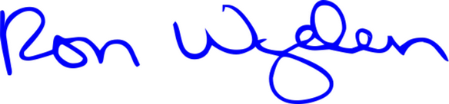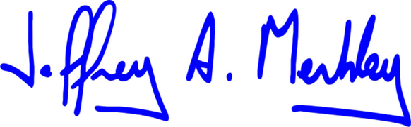

United States Senator United States Senator